







UID /head/

ReadySetResource.com

Contents

15.1 - Dashboard 3

15.2 - Incomes 4

15.3 - Expenditures 5

15.4 - Profit Analytics 6

15.5 - Employee Management 7

15.6 - UID /head/ Work Log 8

# 15.1 - Dashboard

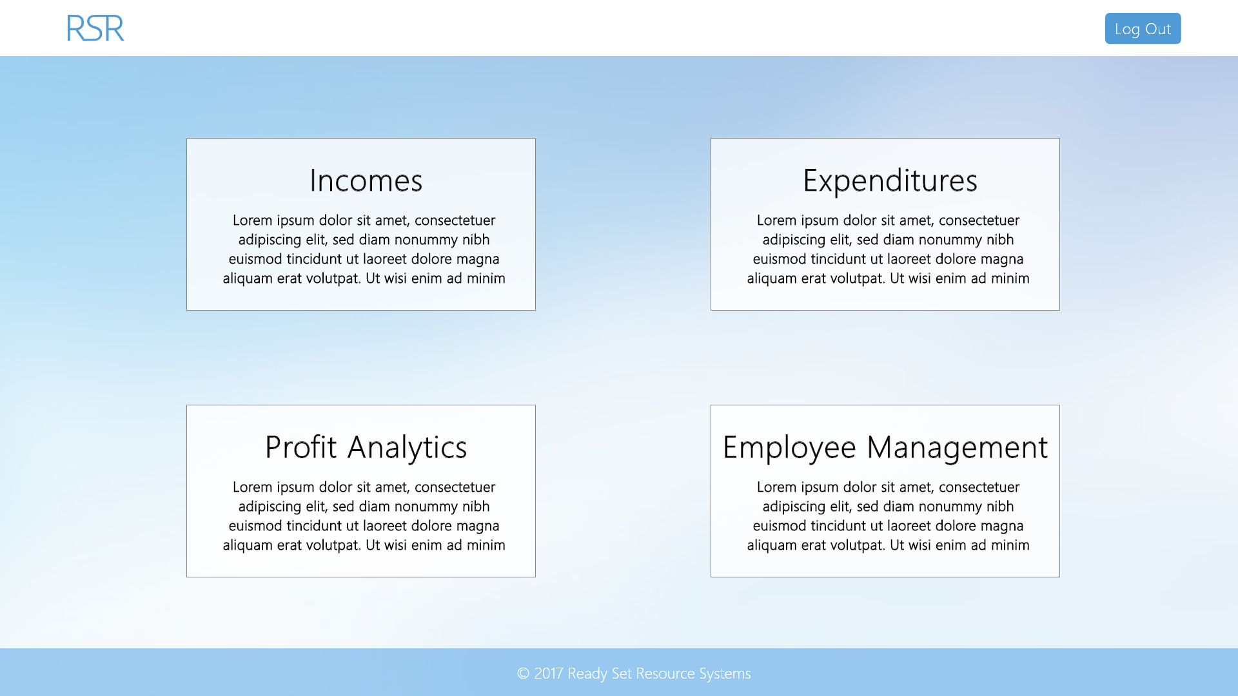

Input Permissible: None

Error Messages: None

# 15.2 - Incomes

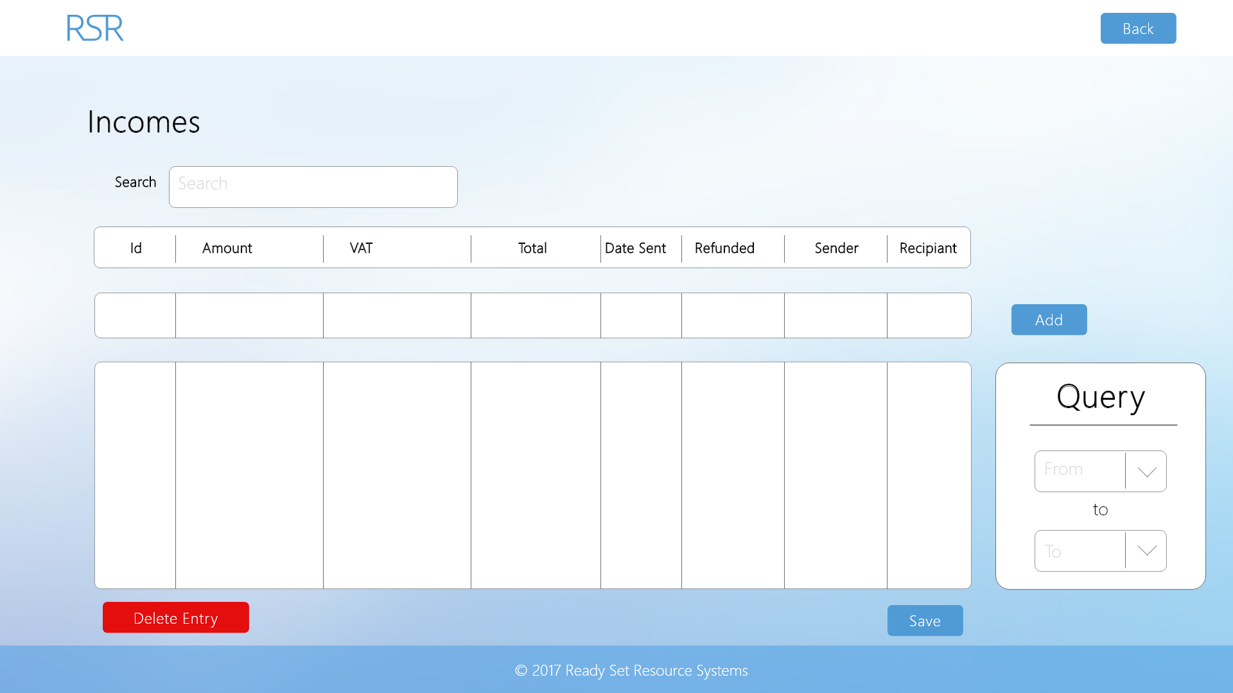

Input Permissible: - Date From

- Date To

- Amount

- VAT

- Total

- Date Sent

- Refunded Date and Time

- Sender

- Recipient

Error Messages: - ‘Cannot select a date before start date’

- ‘Cannot have non-numeric values in amount’

- ‘Date in wrong format’

- ‘Amount, VAT, Total, Date Sent, Sender and Recipient cannot be blank’

# 15.3 - Expenditures

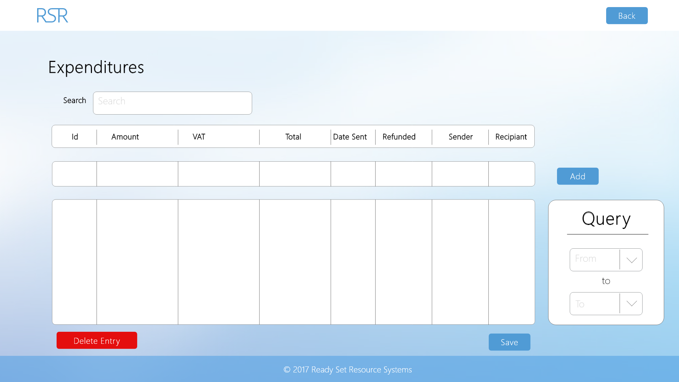

Input Permissible: - Date From

- Date To

- Amount

- VAT

- Total

- Date Sent

- Refunded Date and Time

- Sender

- Recipient

Error Messages: - ‘Cannot select a date before start date’

- ‘Cannot have non-numeric values in amount’

- ‘Date in wrong format’

- ‘Amount, VAT, Total, Date Sent, Sender and Recipient cannot be blank’

# 15.4 - Profit Analytics

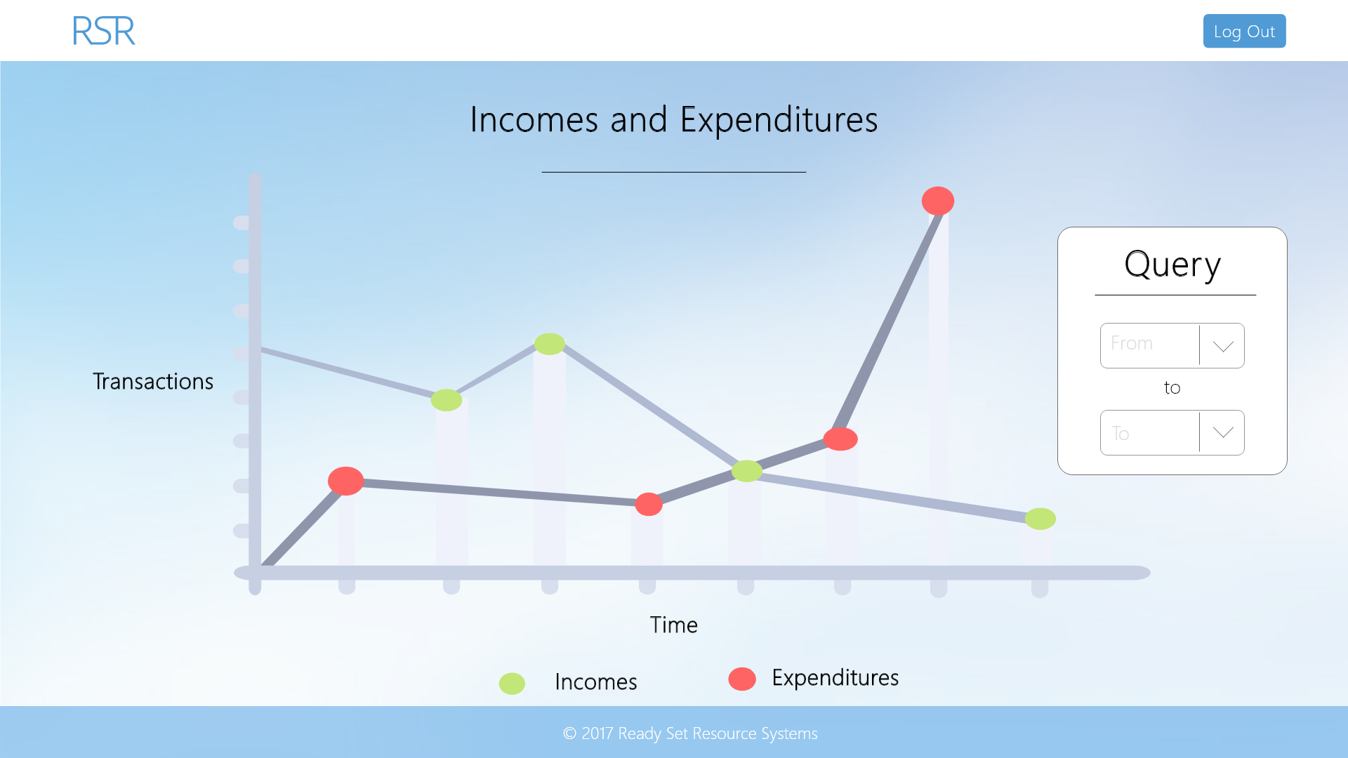

Input Permissible: - Date From

- Date To

Error Messages: - ‘Cannot select a date before start date’

# 15.5 - Employee Management

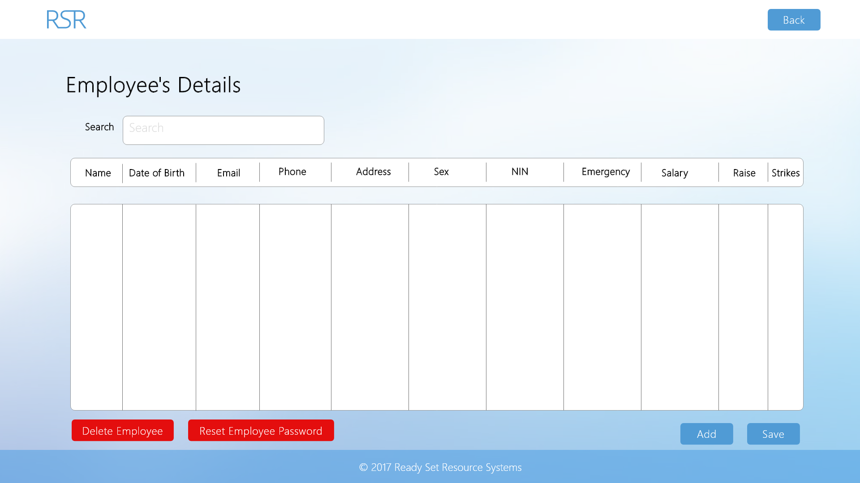

Input Permissible: - Name

- Date of Birth

- Email

- Phone

- Address

- Sex

- NIN

- Emergency

- Salary

- Raise

- Strikes

Error Messages: - ‘Cannot select a date before start date’

- ‘Phone field must be 4 digits for country code, space and number’

- ‘Date in wrong format’

- ‘Please fill in missing fields’

# 15.6 - UID /head/ Work Log

| Entry | Description | Person | Date | Mins Spent |
| --- | --- | --- | --- | --- |
| 1 | Formatted the document | Aidan Marshall | 19/3/18 | 8 |
| 2 | Designed the website | Aidan Marshall | 19/3/18 | 44 |
| 3 | Added screenshots and page details | Aidan Marshall | 19/3/18 | 17 |
| 69 | | | | |